**The Life of A *Quaranteen***

**Author** Aryaman Taparia   
**Editor** Sakshi Lakhotia  
**Illustrator** Suhani Nawalkha

This book is dedicated to my lovely mother,   
who understands me, encourages me,  
and stands by me through it all.

“When a photographer can't change a scene, he changes his angle and lens to capture the best of that scene. Similarly, when you can't change a situation in your life, change your perspective and mindset to get the best out of that situation.”

- Anonymous

**About the Author**

Aryaman Taparia, born and bred in India, is a good student and a good son. He is currently studying commerce at The Cathedral & John Connon School. He resides with his family in the city of Mumbai. A lover of music, he is also a trained pianist and singer. He likes the occasional yet competitive game of chess and table tennis. An average day in his life includes being around nature, exercise and meditation. A life goal for him is to balance the inequality that exists in the world. He believes that it is the privileged person’s responsibility to empower the underprivileged.

**About the Book**

A teenager from Mumbai, Aryaman Taparia has started categorising himself as a *quaranteen* due to his current condition - being quarantined. He has been living with his parents and grandparents within the comforting walls of his home. He has been within confines like never before. He has not seen his friends, sat by the sea or walked in the school corridors in a long time. It started as an attack on freedom but went onto becoming an evolution of the mind for him. A shift from anger to acceptance.

In this book, Aryaman explores his quarantine metamorphosis in *four* stages:

* The Attack
* The Anger
* The Acceptance
* The New Beginning

**The Life of a *Quaranteen***

|  |  |
| --- | --- |
| ***Chapters*** | *Page* |
| *Stage 1: The Attack* | *1* |
| *Stage 2: The Anger* | *7* |
| *Stage 3: The Acceptance* | *13* |
| *Stage 4: The New Beginning* | *19* |

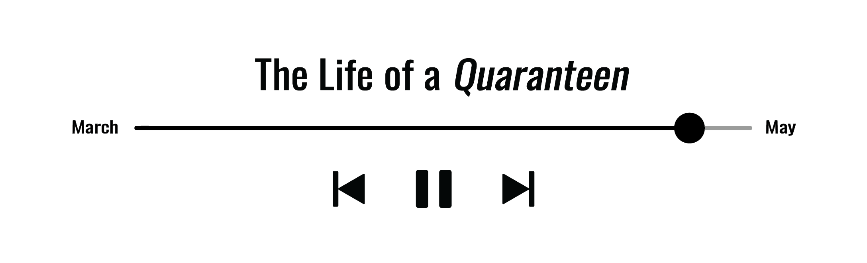

**Stage 1: The Attack**

It was Monday. A day that - the average resident of Mumbai city *-* resonates with pressure and traffic; instead it marked the third day of a nation-wide lockdown.

A total shutdown has confined the populace within their houses. It has disturbed schedules and disrupted routines. It has also changed the *very* definition of being. It felt like an attack on freedom (of everything) at first and in many ways, it was. But it has proven to be something worse - a hazard to health and thus, life. Still, it is lurking around, haunting the living with its lingering taint of death. It has taken over the world like Napoleon had seized power of Western Europe.

And, this terror is a deadly virus. It has introduced mankind to another terrifying global pandemic since the Spanish Flu of 1918. A contagion without treatment or vaccination, it is transmitting from infected to healthy persons like wildfire. It has acquired recognition in the world as the Coronavirus or COVID-19.

As the world is transforming, the teenaged youth is growing disgruntled. A change in their lifestyles is hard to accept. A forceful adjustment to this new way of being is tough for them. This is an uncertain halt in their certain lives. As teenagers, they have earned more decision-making power than ever; they have finally got ahold of the reins to decide and to do. They have gotten accustomed to independent living. But, due to being quarantined, they are not able to exercise this authority. It is the same as living in a prison without having committed the crime. And so, they have started identifying themselves as *The Quaranteens*.

For *the* *quaranteens*, social distancing was an alien concept before it happened. It was unfamiliar and unreal. Even the thought of being caged inside enraged them. After all, this was an attack on their freedom to exist. Earlier, in the pre-lockdown period, they bonded over having things to do in alliance. As a result, the inability to step out of their homes seems absurd to them. It is like being the protagonist in a film with a prolonged intermission. But, it is also oddly comforting for some to know that this is not a personal attack on them. There is enough proof to establish that the whole world is going through this and that the threat is quite real.

My name is Aryaman and I am one of them for two reasons: shared age and anger. I have been undergoing emotions similar to that of many seventeen-year-olds. It is a novel crisis for us. As they expressed their boredom and ridicule stemming from this crisis, I realised I was not alone. It became especially apparent with the virus-centric memes and videos that have taken over the modern media. All of mankind is being affected by this outbreak. It was knowing that ‘we are all in this together’ that further eased my anguish, but even so, it is surreal being far from society until the lockdown has been lifted.

A great deal has changed. As individuals have been limited to living in their own addresses, the outer world is not the same. All the hustle-and-bustle of city life has come to a standstill. Even the schools and malls and public places have been shut. And, with the cessation of social life, I have had to abandon my old routine. It was an era when my friends and I had activity choices. We hosted fortnightly brunches and game nights. In the evenings, we walked along the waves at the PD Park and talked. On occasion, we debated recently released movies and television shows on Netflix. But now, we are bounded by in-house entertainment.

After the first week of being quarantined at home, I had exhausted my to-do list. I had finished writing a 1500-word essay on ‘Sustainable Development in India’ for my economics class. I had perused the *God’s Debris* by Scott Adams quicker than any other book. I had practiced playing the piano after ages, too. It is a favourable time to polish my skills as a pianist. I have zilch commitments. I have nowhere to rush to anymore. And so, I invested hours on the ebonized bench of the Steinway & Sons acoustic upright piano. My fingers fatigued from rehearsing Tiersen’s *Rue des Cascades* over and over again. It is my all-time favourite album.

Although the initial days went by smooth as a whistle, it got worse. At first, being locked down was regarded as a spring break. It was mid-March and we needed to escape from our fast-paced lives. It was a relief to be home and relax. But, as most were expecting the virus to die down, it turned more powerful. It was in the news but was also being experienced first hand by some. Soon, it had reached my area of residence. As I peered down the window that day, I saw an army of ambulances and police cars. They were sealing and sanitising the whole building. It was like a scene from an apocalyptic film, but more horrifying than thrilling.

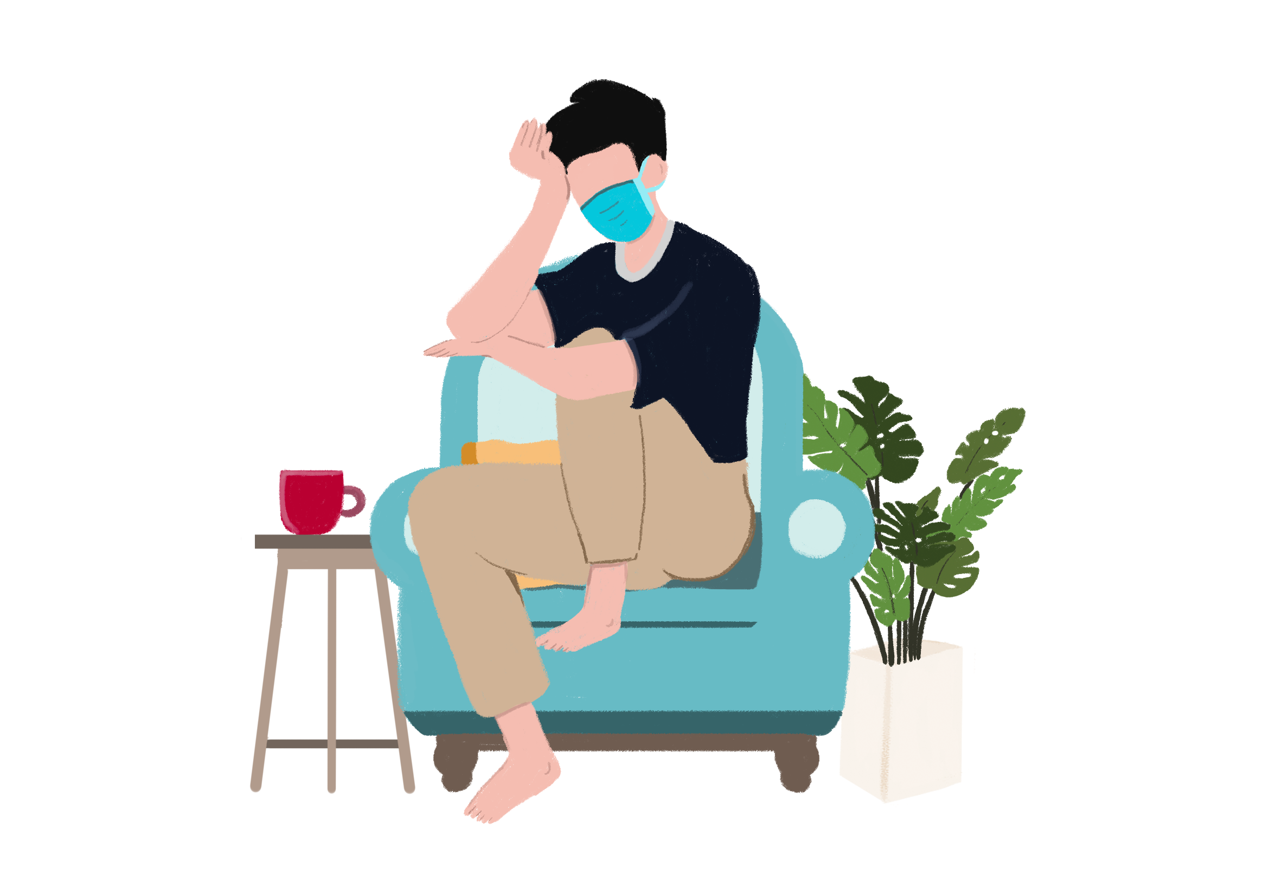

After the lockdown, the government had imposed several other regulations. A first measure was to prohibit travel both domestic and international. It is fairly justified to restrict movement as a strategy of containing the spread of the disease. But, it is difficult for us *quaranteens* to live without migration as an option. We wanted to explore the world. We were looking forward to our summer holidays, so we could escape the humid weather. We longed for the Marine Drive breeze to hit our faces while riding in *kaali-peeli* taxis. But, it was not an option for us or the 1.33 billion Indians under lockdown.

A travel ban has its consequences. Along with irritability amongst the population and minor protests on the streets, there have been other noteworthy reactions. An example of this is the airline industry. As hangars were running out of storage, the flights were parked in the runways. A sight where a sizeable number of aeroplanes were stationed in the open space had never been seen before. These vehicles have grounded after many miles of motion. It became a trending topic for a while, too. It was a historical moment for the world of air transport. It was also an indication of the fact that life was not moving for anyone anymore, not even transportation.

The Economy of India has been impacted by this crisis as well. It is suffering due to the suspension of trade. It was an anticipated ramification to this lockdown. A grinding interval to commerce has brought down national growth. It has affected people, their lives and livelihoods. A large segment of the population has either lost jobs or customers. Even the demand for fuels such as petrol and diesel have slumped. All these damaging effects have given this crisis another title: The Great Lockdown; as it is reckoned to be the “worst economic downturn since the great depression” by the International Monetary Fund.

Even migrant workers were travelling back to their home towns and villages. As households turned away house-help and organisations laid-off their workforce, the unemployed were desperate without any steady income. They lacked the means to survive in the bigger cities. Some trekked on foot for thousands of kilometres and others cramped in buses headed to their destination. They went on with the hope of being reunited with their families. At first thought, this action came across as emotionally reasonable. But, it was a strangely ironic outcome to a lockdown - the masses moving across states and endangering their health without protective gear.

One night, we were sitting at the dining table when my father mentioned that the victim cases for COVID-19 were on the rise. He also shared that the “situation in Italy was uncontrollable but with rapidly surging cases in India, it is important to be cautious at all times.” I asked him how he got the data on the number of cases. He revealed that live-update websites such as worldometer.com can be deemed as credible sources to discern the severity of this crisis. It was nine o’clock. The food had been served and the discussion had stopped. It was time to move on from the virus-centric conversation. But, I was curious. I had my phone under the table, so I looked for data on the website he mentioned. I realised that the figures had been changing with every refresh. As digits multiplied, the panic in my head did, too. I sensed my despair augmenting with each infected person. I had concluded that the pandemic-driven lockdown is here to stay. It was not normal. It was definitely not a vacation. In fact, it felt like the end of the world.

**Stage 2: The Anger**

I hadn’t even twisted and turned yet when I heard my mother call out my name. It was half-past eleven in the morning. She had summoned me to the breakfast table and she sounded unusually furious. Initially, I had deduced that the reason for her rage might be my wake-up time. I took a glimpse at the lock screen of my phone. It was late. But, I had been waking up at this hour for longer than one week. It has become my quarantine routine. I did not have much to do anyhow; with school closed and friends restricted to their homes, I had no schedule.

After tumbling out of bed, I looked at the windows in my room and squinted. The windows occupied three-fourth of the wall. A strong pre-noon light pervaded the space and sight. I had a flashback that before going to bed last night, I had drawn the curtains close. And, I expected to find them drawn the next morning, which is now. But, they were wide open, allowing the sunshine to pierce through with ease.

I trudged out the door only to be bombarded with more sun-rays. I was blinded for thirty-seconds before regaining my vision. I looked at the heavy trees that fortified our apartment building. They were swaying with the light winds of April. It was a pleasant view. As I turned to the other side, I saw my mother seated at the head of the table. She, on the other hand, did not look pleasant. I went to the table and sat next to her. She said that “this has to change” and “waking up at odd hours is not healthy for the mind or the body.” But I disagreed. I did not have any plans to get through the day. “Why should I have to wake early?,” I thought.

As mentioned before, it feels like this world of ours is ending. And, with its death nearing, I have zero motivation to keep going at it. I did not feel the need for any planning. I did not want to argue with my mother either. We lived together now -more literally than ever. A split second later, I zoned out. I started thinking about a time where I had things to do without being forced to. I had school to attend early in the day. I had mathematics and piano tuitions on weekdays. I had friends from my building to hang out with on weekends. But, times have changed.

After two slices of bread with peanut butter and a small bowl of *poha*, I returned to my personal den: the bedroom. It was messy. It looked like it needed hours of scouring and scrubbing to be clean again. I had considered doing it myself before dismissing the idea within seconds. Then, I dove back into the untidy bed. I stared at the door to my bathroom and then the back at the screen of my phone. A whole hour had gone by like this. It was one o’clock. I was bored. I pondered over taking a shower before looking for things to do. It would be far more interesting than just sitting. It would also make my mother happy. I decided to leave my comfort zone with a ‘why not’ and made my way to bathe.

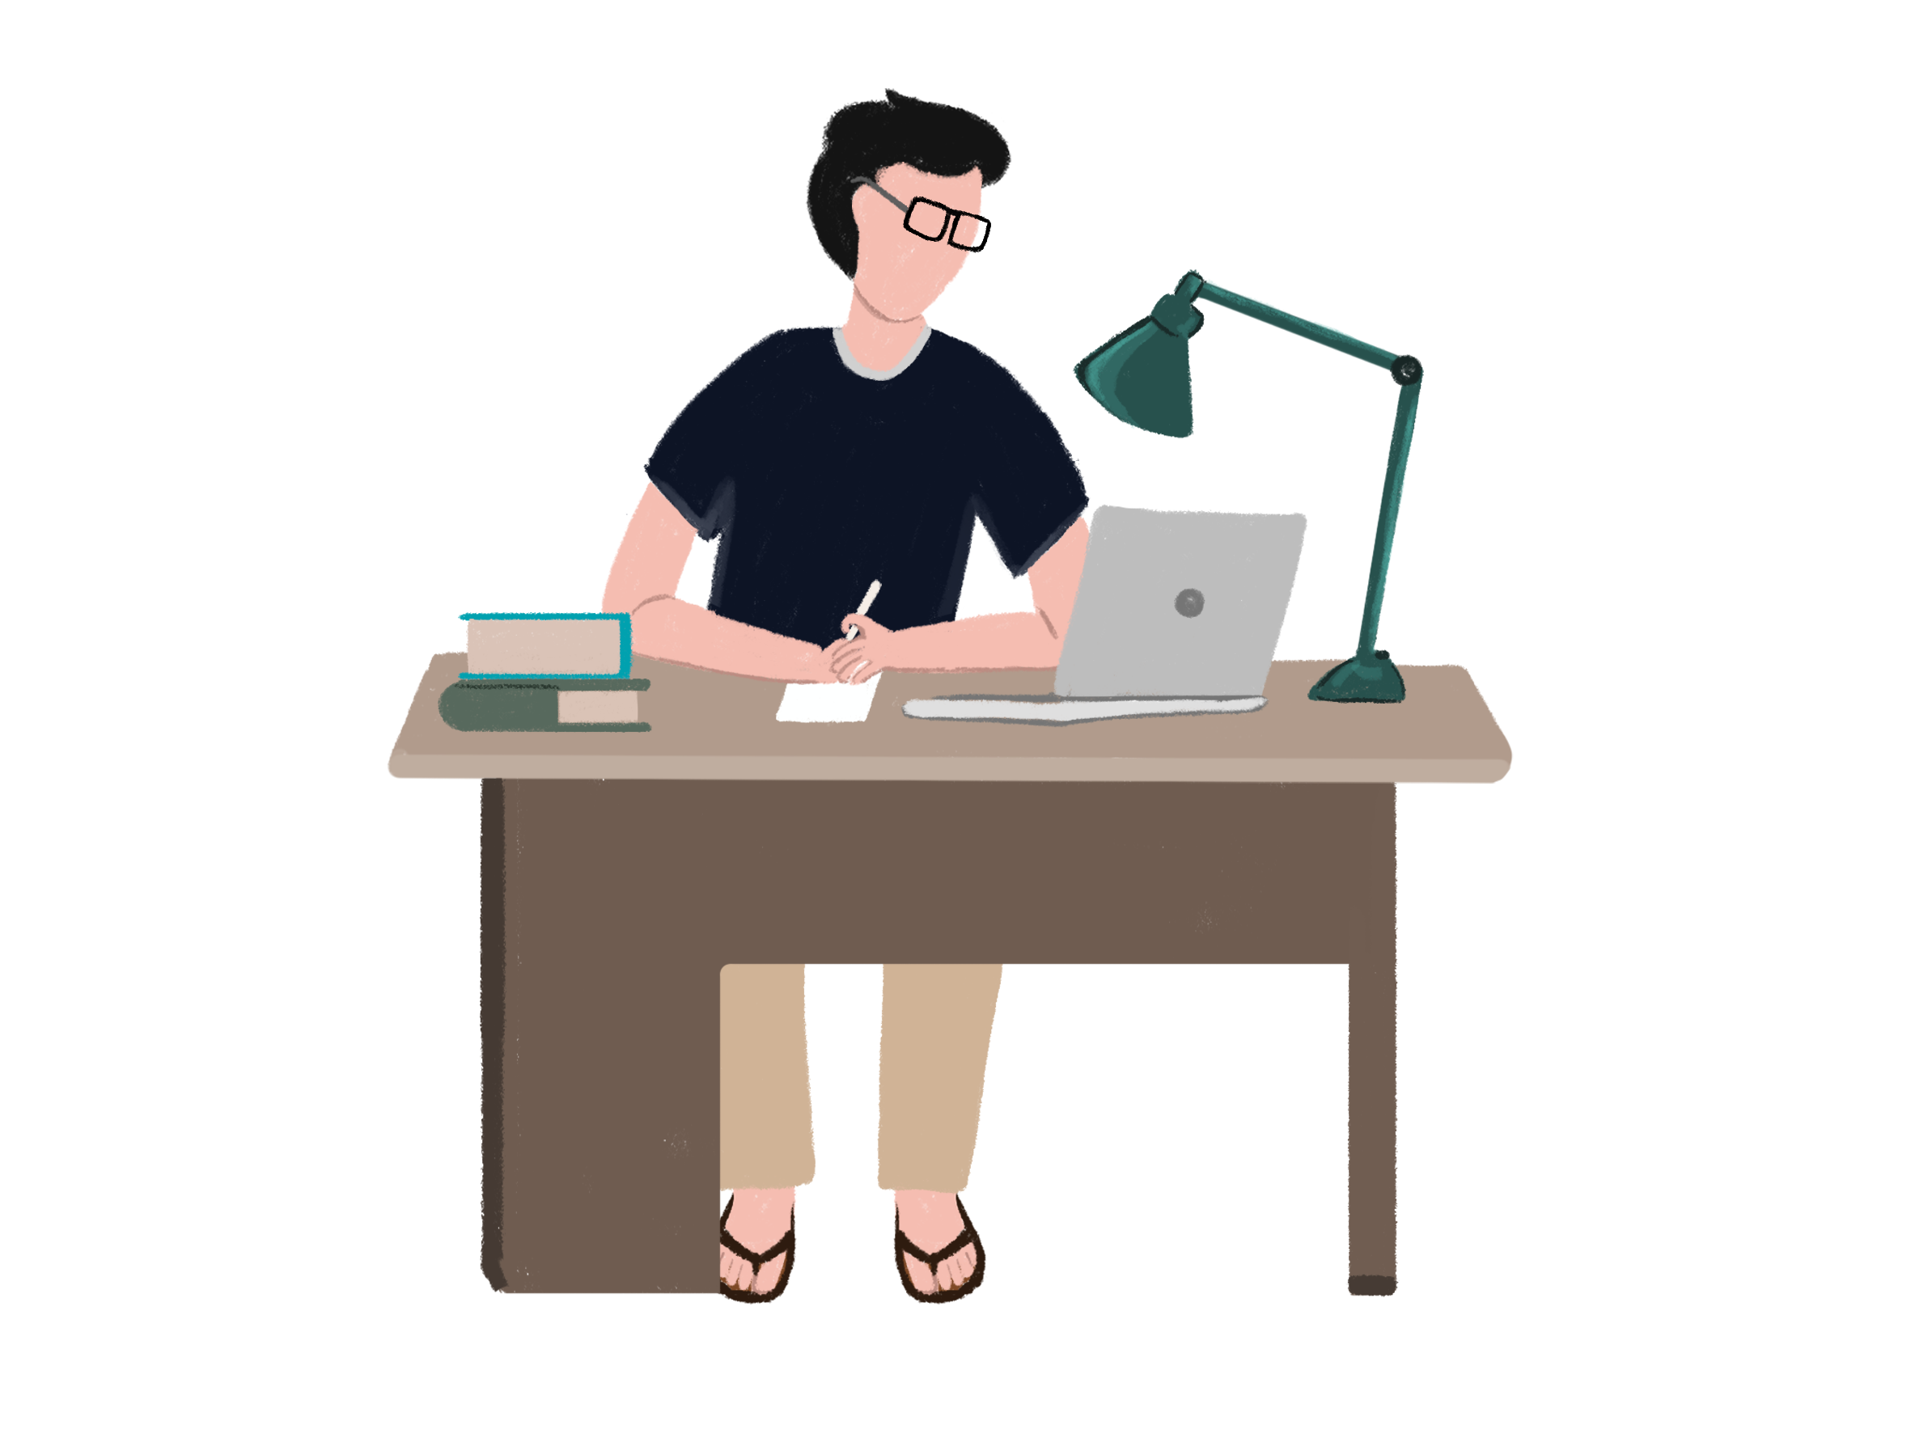

I have found myself lost in transit - from freedom to captivity. I have been indoors for three whole weeks now. I feel overwhelmed about adapting to this strange way of existing. I look at the entrance door and think about exiting from it, sometimes. I think about the upshot of stepping out of the house even for a short while. It stirs an internal turmoil in me. I have been living with the fear of being attacked by this virus. But, I did not want to anymore. I have, every once in a while, pleaded with my parents to allow me to step out. I cannot foresee any damage in meeting with two or three friends. But, all my attempts at reasoning this demand have failed.

I have missed out on occasions and opportunities because of the lockdown. I have been caught in the virtual web of existence. My limited methods of entertainment are the kind that require being connected to electrical energy. I have the luxury of digital diversity to choose from. I possess a phone, tablet and laptop. But, it is not remotely as gratifying as resting on lush green grass while inhaling fresh oxygen or sitting in movie theatres and chowing down kernels of salted caramel popcorn. Even cyber conversations are not satisfying. A video call strains my eyes and arms the same way it does my patience. As my memories fade away due to the distance, I feel aggrieved. I haven’t been away from my peers this way. If given the choice, I would opt for a face-to-face dialogue over a virtual vis-à-vis. I keep cudgelling my brain about why this is too much to ask for.

I believe that as a teenager approaching adulthood, I have the ability to steer clear of this dangerous virus. I have made many efforts to communicate the suffocation caused by being locked-up. I have broken down into tears and drowned in them as well. But, my parents - overprotective as they are - refuse to give in. They would just not let me out of the house even for a minute.

The infamous COVID-19 virus has stirred up a hornet’s nest in the lives of many, including my own. It has taken over the newspapers and channels. It is not just the talk of the town but the talk of the world. It is the bitter truth that the people must know. A fragment of humanity is also drowning in this flood of information about the virus. It is on the tip of their tongues. It is all that anybody talks or jokes about anymore. And, the excessive coverage of this virus makes me fear it even more. I want to concede defeat if this was a plausible course of action.

I hear about instances of carelessness in the media. Some people with irrationally positive attitudes have been indifferent to the government’s warning. And, despite the threat, they have not been cautious. They have been living freely. It is because of this negligence that they have endangered many lives - their own, their parents and strangers. Along with this impact of unawareness or disobedience, they have delayed the progress of eradicating the pandemic. I have always believed in being optimistic. But, positive thinking does not exist without a hint of reality. It can be damaging to overlook the facts, no matter how unpleasant they might be.

My heart goes out to the daily wage and health workers. In varied ways, they have both lost and continue to lose as a result of this catastrophe. I feel a wave of anger within me when I think about those who have lost friends and family to the virus. I feel pain in my chest when I imagine them grieving without ever getting a look at the corpses of their loved ones. I think about the aftermath on businessmen with hefty loans to pay back. I think about their families. It is spine-chilling to visualise the trauma that the world has been undergoing in the last few weeks. A burden is weighing the planet down and it cannot be seen. It might be invisible, but it exists. It is devastating for not one, but all.

It has been three weeks so far and being home has become the new “normal” for me. I have not been in touch with the outside world in a long span. I keep thinking about if and how drastically it has changed. While the political and fiscal impacts of this lockdown have made the headlines, I still wonder how the average man is coping in this time. I try to imagine restaurants without diners and hotels without guests. I am convinced that this pandemic will define the year of 2020. It will be added to the list of 21st-century pandemics after the H1N1 Influenza and SARS in history textbooks. It will be broken down into phases: pre-corona, during corona and post-corona. It will be addressed as another unfortunate episode of this age.

**Stage 3: The Acceptance**

A whole year ago, I had taken my first step toward a life-changing practice. It was in the month of May that I had been introduced to the act of meditation. And, little did I know that this cathartic method would become an integral part of my being someday. It has evolved my mind and soul. It has lifted my spirits and allowed me to surmount hurdles, time and again. It has been an enlightening experience. It has also finally freed me from the perils of being a *quaranteen*.

As the lockdown in India got extended for the third time, I had committed myself to be calm and composed. It had been labelled as the ‘Lockdown 3.0’ - a sardonic attempt at attacking the government for protecting its people. But for me, it wasn’t the same. Earlier, even without intending to, the virus succeeded in disrupting my mood. It controlled me like a puppeteer held a puppets’ strings. As I did not want to be agonised over it anymore, I resumed meditating for 30 minutes every day.

My journey with meditation had started after my board examinations. Before that, I had not even considered this path or practice. It never struck me as a panacea to life’s problems. It was an exacting interval for me - tests after tests - that required hours of preparation. As time ticked by, I lost count of the insomniac nights. There were too many. But, I did not predict this pressure to persist into post-stress stress. I had expected it to recede soon after. I had also imagined exiting the examination hall, liberated. Instead, from worrying about performing well to worrying about *if* I had performed well, my mind turned anxiety-ridden.

As my parents have been avid practitioners of meditation, I was inspired to give it a try. I had witnessed them gain control over nerve-racking situations before. I had observed that even the most worrisome circumstances failed to hurt their peace of mind. And, I desired that level of self-control; the ability to stay calm. I wanted to remain composed in all situations - whether good or bad. In this case, I recognised that I did not want to be high-strung if I had aced my exams or not. I wanted to be grounded. I wanted to retain that balance in life. I wanted to break away from this web of impatience. I had a heart-to-heart with my mother that day. She had shared instances from the four times that she had done a meditation course.

Soon, I found myself entering the *Dhamma Sarita* in the outskirts of Mumbai. It is one of the many renowned ‘Vipassana Meditation’ centres in the country. A haven away from the congestion of city life, it stands by the banks of the River Bhatsa. It was minimalistic. I had a good feeling about this eight-day silent *Anapana* course. Here, I learned the technique to focus on bodily sensations: pleasure and pain, and my breathing. Also, I had a disciplined schedule. It was not particularly easy. But, it imparted the *very* trait that I had been looking for: equanimity.

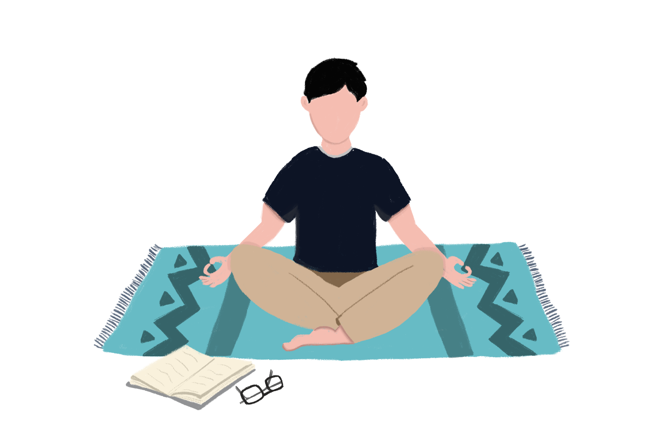

It was Day 38 of the lockdown. I had sensed that the house-help were undergoing discomfort. Even with the security of food and shelter, they were not satisfied. As they had not left the house in a long time, they were eager to do so. But, they were constricted to the eighth floor of our building. So, to steady their nerves and assist them in accepting the common problem, I held meditation sessions. I guided them with the teachings of my *guru*. At the same time, I took walks down memory lane. I recalled greeting insects - from spiders to lizards - in my room at the meditation centre. I had coped with this fear through observing my sensations. I had attained the patience to sit through *pravachans* or preaching sessions, too.

I believe that I had undergone an evolution of the mind after the silent meditation course last year. It changed me. It allowed me to connect with real life. And, while that one disciplined week invoked self-awareness, it also turned me into a calmer individual. I had become emotionally and physically conscious. It was in this time that I had inculcated the art of reflection and introspection as well. I had not only acquired the skill to calm down but also help others do the same. And so, this self-imposed lockdown from last year has helped me to subdue the suffering stemming from the present-day forced lockdown.

Earlier, I had given overthinking the consent to drain me. It pushed me away from a constructive existence. It diminished my productivity. It made me waste time on fretful whimpers. But, with meditation, it has been possible for me to contain my apprehension. I have understood that there is no escape or refuge from the virus. It has surfaced for unknown reasons but exists anyhow. I have realised that to be anxious is to be human and it can be overcome. And now, rather than wresting the uncontrollable forces of nature, I am simply co-existing with them.

Along with meditation, I have also adopted a healthy routine. It is not as stringent as the one at the Vipassana centre. There, I was awakened by the morning gong at 5:30 a.m. and went back to bed at 9:30 p.m. It was an extreme schedule to follow at home. It was also uncalled-for. But, I have established a lifestyle comprising of online schooling, playing the piano, reading the newspaper and novels, meditating and spending quality time with family. As the rhythm of music tranquillises me, it permits me to connect with the inner self, too. It brings me solace. I have started singing more often. In the evenings, I have revelled in listening to melodies with my grandparents. I believe that the respected playback singer, Lata Mangeshkar is truly a nightingale in human form. Her voice soothes the soul in a busy city such as my own. It bestows me with hope.

According to me, the lockdown period is a detox. It is a lot like the *karela* or bitter gourd - a vegetable fruit that tastes bad but is good for health. In the same manner, being quarantined might be a challenge, especially for *quaranteens*, but it is also a blessing in disguise. It is high time to accept this transition and flow along with it. It is an opportunity for humankind to revive as well as thrive in conjunction. It is a chance for *Homo Sapiens* to dwell on the positive reasons to living in this world. I have become accustomed to this sanguine outlook toward the Coronavirus attack. Along with seizing the days, weeks and months of the lockdown, I am gearing up to resume life like it used to be. And, while I still want life to go back to normal, I will choose to be kinder this time toward our precious planet and people. I will have more gratitude for my blessed life. The Vipassana meditation has helped me realise we must breathe and be in the here and now; not the future or past. And so, I have started straightening out problems instead of burying them like I did earlier.

A strangely damp afternoon in Mumbai seemed erratic to me. It was Monday, but it was also an irrelevant detail in this lockdown. As the ‘days of the week' concept lost its charm, the people lost track of it, too. My family and I were settled next to the television in the living area. We had occupied ourselves in our own activities. I was scrolling through Instagram on my phone. But, the news channel was on. We looked up in synchronisation as an alarming headline was verbalised. It was in the news that the State of Maharashtra had “recorded the biggest single-day jump in coronavirus cases with nearly 3000 testing positive” of the viral disease. It called for the public to be more attentive. I agreed. But this time, it failed in tormenting me. It did not make me furious. I had finally made peace with it.

**Stage 4: The New Beginning**

As life relocated from the outdoors to indoors, the world changed. It was different. It was manless. And, the lack of human activity had striking repercussions. In this time, the streets had started looking like mere layers of asphalt, bitumen, and tar; the *same* streets that once connected people and places had now embodied a bleak emptiness. Although they looked alone - without humans or vehicles - they were never lonely. It was a much-needed halt in the lives of these concrete pathways. A break from the heavy buses pressing down on them; from cars and bikes spewing out fumes on them; and from pedestrians hastily treading on them. If they could, they would express their immense appreciation for this.

Even the animals were enjoying the quieter world. The Macaques had taken over the streets of Lopburi, Thailand. The wild deers have made themselves at home in the empty lanes of Nara, Japan. It has become a better world for all living beings.

A glance at the skies would leave any sightseer stunned. Even the world’s ceiling seemed to have bathed for a change. It was cleaner and clearer than ever before. It had birds soaring into and out of clouds. It had stars hovering above in the sunless evenings. It had mastered the impeccable imitation of *A Starry Night*. If the Dutch painter, Vincent van Gogh could witness this rare setting in the otherwise polluted city known as Mumbai, he too would be startled. At one point, even the ‘Weather’ app on my phone had changed its AQI (Air Quality Index) status from hazardous to healthy. It was astounding.

While flowing with the unseen currents of the lockdown, I had absorbed the value of minimalistic living. It was living within the means that made me appreciate life and all that it has to offer. I learned that luxury is not a necessity. It can be used to elevate lifestyles, but must not be depended on. I have discovered the significance of the “little things” in life. An hour of the card game *Canasta* or a cup of tea with grandparents is irreplaceable. A casual yet intense debate on politics with parents is priceless. All these teenage years had gone by in giving needless attention to the things that never mattered. And now, I am aware of that.

It is the sixth week of the lockdown. The people are bracing themselves to living in harmony with the pandemic for as long as they have to. The businesses are also restarting their outlets. As life in India is gradually getting back to normal, I have made the conscious effort to adjust my own lens rather than amend unfavourable circumstances. I have learned that the moments that I had previously neglected are precious. And, despite these microscopic parasites still walking the earth, firing at the young and the old, attacking the weak and the strong, I know that there will be a tomorrow and that too a bright one.

**About Meditation**

**Anapana**

An age-old Buddhist technique, *Anapana* focuses on “mindfulness of breathing”. Also, it is the first step in the practice of Vipassana Meditation. It has been proven that practising this meditation for 10-15 minutes twice every day has innumerable benefits. Here is how you can practise this method:

**Step 1:** Sit in a comfortable position with your back and your neck straight.   
**Step 2:** If you wear glasses take them off.   
**Step 3:** Keep your eyes gently closed.   
**Step 4:** Keep your mouth closed.   
**Step 5:** Focus all your attention on the entrance of the nostrils.   
**Step 6:** Remain aware of the natural breath as it comes in, as it goes out.   
**Step 7:** Don’t try to control or count the breath.   
**Step 8:** Don’t add any word or imagination of any kind.   
**Step 9:** If the mind wanders away, bring it back to the awareness of your breath.   
**Step 10:** Try to remain aware of each and every breath that comes in and goes out.

**Benefits of Anapana Meditation**

1. Improves concentration   
2. Increases alertness   
3. Develops control over the mind   
4. Memory becomes clearer   
5. Improves decision- making ability   
6. Increases self-confidence   
7. Agitation, fear, tension, nervousness and stress decrease   
8. Capacity to work and study increases   
9. Increases ability to understand others and to express oneself   
10. Mind becomes healthy, wholesome and strong   
11. One becomes full of good wishes for others.

**Metta Bhavana**

A form of meditation in Buddhism, *Metta* means ‘loving-kindness.’ It is suggested to practise this method after Anapana meditation. It helps with increasing positive emotions and decreases negative emotions. It is performed by mentally repeating the following words:

May I be happy, be peaceful   
May my mother be happy, be peaceful   
May my father be happy, be peaceful   
May my brothers and sisters be happy, be peaceful   
May all my classmates be happy, be peaceful   
May all my schoolmates be happy, be peaceful   
May all my neighbours be happy, be peaceful   
May all the people of my country be happy, be peaceful   
May all the people of the world be happy, be peaceful.

**5 Precepts**

As part of the Anapana course, practitioners must take five precepts (promises). Here are the precepts:

- Abstain from killing   
- Abstain from stealing   
- Abstain from wrong behaviour  
- Abstain from wrong speech such as lies, harsh words, talking badly about others  
- Abstain from intoxicants

You may like to keep these five precepts in your daily life. They will help you in your meditation and also help you lead a happy and harmonious life.

